Novel Biorefinery (Type Your Title Here – Times New Roman 10pt Bold)

Adam A. Author1 (underline presenting author) and Sarah Q. Author-Two2*

1Super University, City, Province postcode (Country)

2Fundamental Research Laboratory, Excellent Company, Site Location,

City, Province postcode (Country)

*s.a-t@excellentco.com (corresponding author designated with a star)

Introduction

A short introduction should be placed here in font Times New Roman, size 8 pt. Citations should be numbered numerically in order as they appear in the text [1].

Materials and Methods

Here a brief description of chemicals and equipment should be reported, along with a description of the experimental procedures, analytical tools and methods of data analysis [2].

Results and Discussion

A report of the key results and their interpretation should be given here. A single line space should separate paragraphs and the same should separate text from tables or figures. Font size is 8 pt.

Table legends are placed above any table with left alignment.

Figures should be inserted as pictures with legend below the figure.

**Table 1. Surface composition via ESCA**

|  |  |  |  |  |  |
| --- | --- | --- | --- | --- | --- |
| **Catalyst** | **%C** | **%N** | **%Ni** |  | **N / Ni** |
| Ni – A5 | 39.8 | 5.2 | 12.7 |  | 0.41 |
| Ni –control | 24.3 | 0.2 | 18.4 |  | 0.01 |

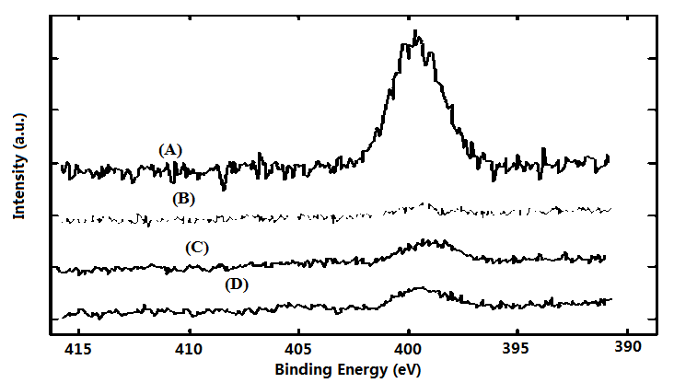

**Figure 1.** **XPS spectra of four catalyst used in hydrogenation of chemical XYZ**

Significance

Authors should highlight in 1-2 sentences significance of the work.

References

1. Periana, R.A., Mironov, O., Taube D., Bhalla G., Jones C. Science 2003, 301(5634), 814-818.
2. Hackshaw, A. How to Write a Grant Application; Wiley-Blackwell: Oxford, UK, 2010.

**The abstract should not exceed one page.**